https://www.perutravelexpertsb.com/tours/city-tour-cusco
CITY TOUR CUSCO.
"Travel with confidence knowing that every experience is carefully designed by local experts who are passionate about sharing the authentic beauty, history, and culture of Peru. Enjoy personalized service, genuine cultural encounters, and the peace of mind that comes from traveling with a trusted local team."

Discover the Heart of the Inca Empire.
This morning you will have City Tour, where we will visit 3 Inca remains and Textile factory where you can feed llamas and alpacas.
Experience the fascinating history, culture, and living traditions of Cusco, the ancient capital of the Inca Empire and one of South America's most captivating destinations.
This half-day guided tour takes you beyond the city center to explore some of the most remarkable Inca archaeological sites while immersing yourself in the rich Andean culture that continues to thrive today.
Your adventure begins with a convenient pickup from your hotel in Cusco. Our first stop is Puka Pukara, known as the "Red Fortress," an important Inca military and administrative checkpoint that once guarded the entrance to the sacred city of Qosqo.
Next, we visit a traditional Andean Textile Center, where you will have the opportunity to meet and feed llamas and alpacas while learning about the ancient weaving techniques that have been passed down through generations. You will also see the elegant vicuña, one of the world's most prized and protected animals.
We then continue to Qenqo, a mysterious ceremonial sanctuary carved into natural limestone formations. This sacred site was used by the Incas for religious rituals, ceremonies, and mummification practices, offering a fascinating glimpse into their spiritual world.
The highlight of the tour is the impressive fortress of Sacsayhuamán, one of the greatest architectural achievements of the Inca civilization. Marvel at the enormous stone walls, some weighing more than 100 tons, perfectly fitted together without mortar. As you walk through its terraces and viewpoints, you will enjoy breathtaking panoramic views of Cusco and gain a deeper understanding of the ingenuity of the Inca people.
After exploring these extraordinary sites, we return to Cusco, where you will have the rest of the afternoon free to wander the charming cobblestone streets, discover local markets, visit museums, or simply enjoy the vibrant atmosphere of this UNESCO World Heritage city.
Why You'll Love This Tour
- Explore iconic Inca archaeological sites with an expert local guide.
- Learn about authentic Andean culture and traditions.
- Meet llamas, alpacas, and vicuñas up close.
- Enjoy spectacular views over Cusco.
- Perfect introduction to the history of the Inca Empire before visiting Machu Picchu.

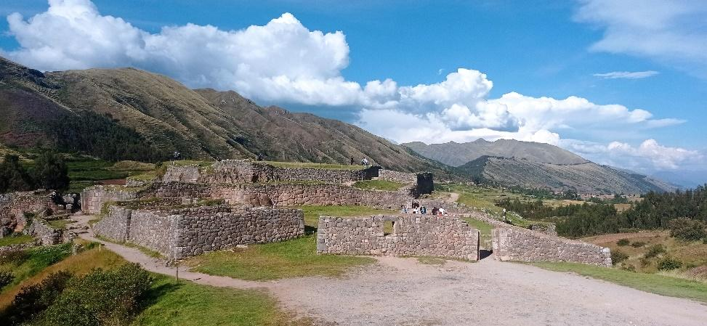
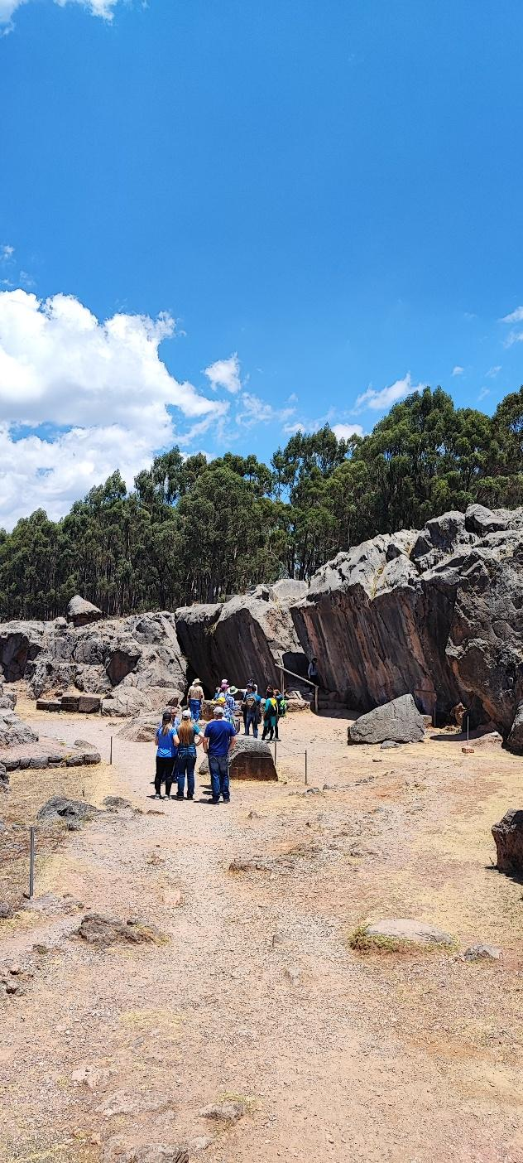

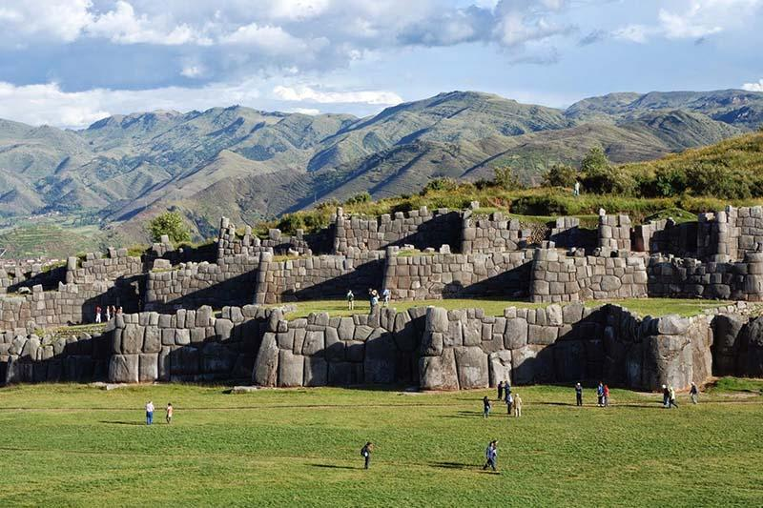
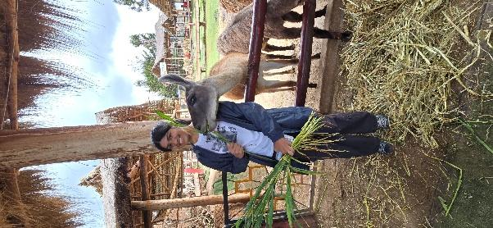
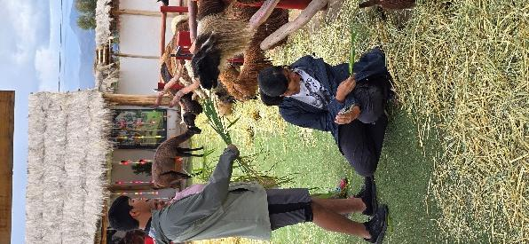

Details of the Day

Departure & Return Location.
Hotel in Cusco City.

Departure Time.
Services start at 8:00 am.

What’s Included.
- Pick-up and drop-off at your hotel in Cusco.
- Private Tour.
- English-speaking professional Tour Guide.
- Entrance fee to places indicated on the itinerary.

What’s NOT included.
- Hotel in Cusco.
- Personal expenses and anything other than what are on the program.
- Meals: Breakfast, Lunch and Dinner
- Gratuities for the Tour Guide and Driver.

Suggestions and Restrictions
Comfortable walking shoes, Sun Protection or rain ponchos, depending on the season, hat, Snacks, and a lot of curiosity.

Tour Price.
Prices are per person and vary according to the number of travelers in the group.

1-2 PEOPLE | 3 PEOPLE | 4 PEOPLE | 5 PEOPLE | 6 PEOPLE | 7 PEOPLE | 8 PEOPLE
$ 129 | $ 99 | $ 89 | $ 79 | $ 69 | $ 69 | $ 69

